**PRACTICAL NO.6**

**Working with Projections and WMS Data**

Layer > Add Layer > Add Vector Layer >

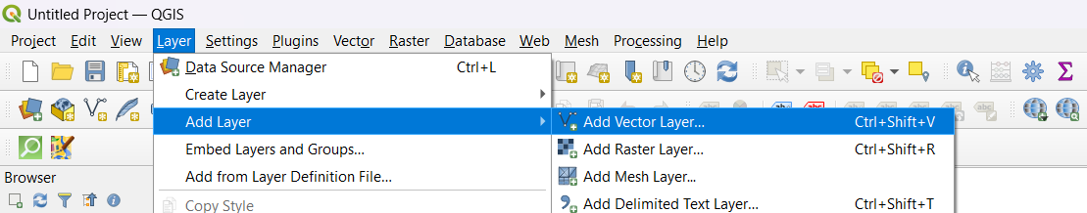

Select ne_10m_admin_0_countries.zip file > Add >

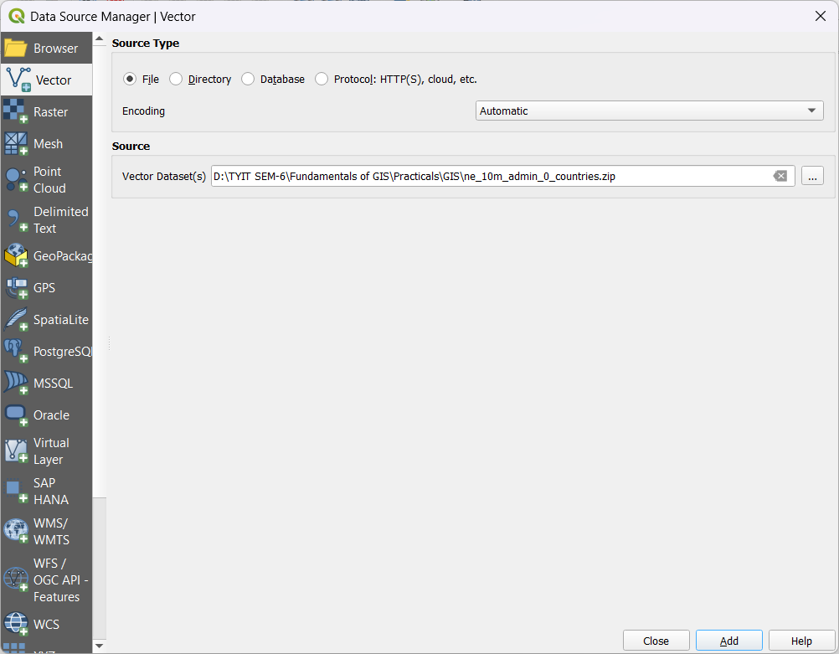

Output After adding ne_10m_admin_0_countries vector layer >

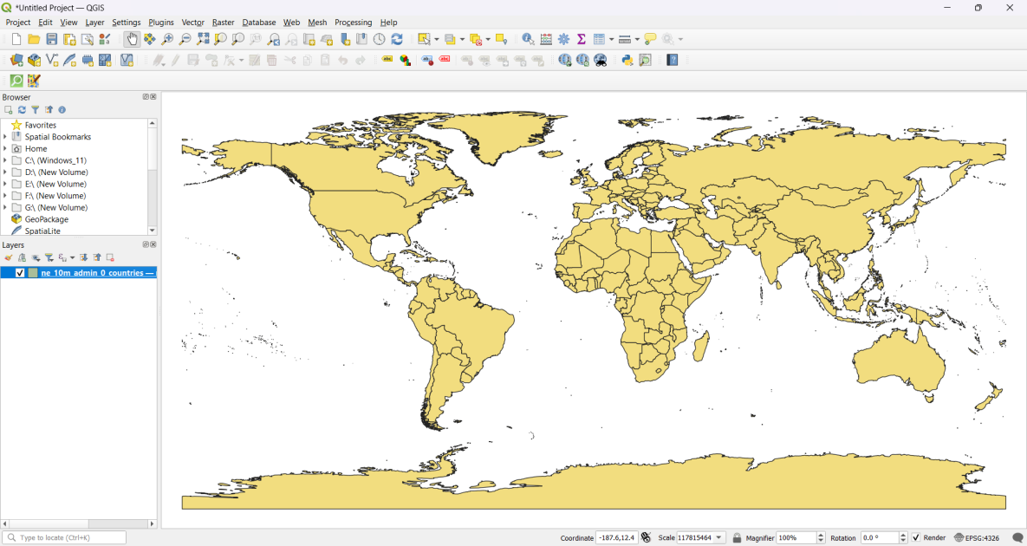

**Change Projection:**

Layer > Save As.. >

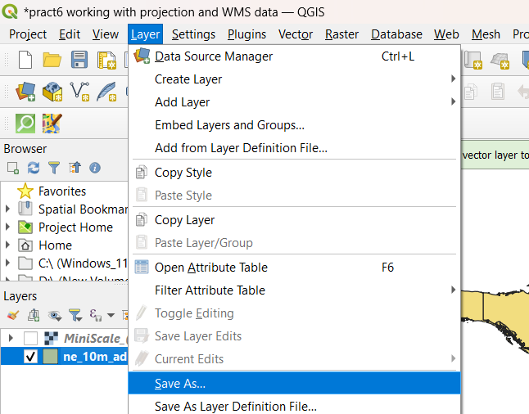

Give File name > At CRS Click Select CRS Option >

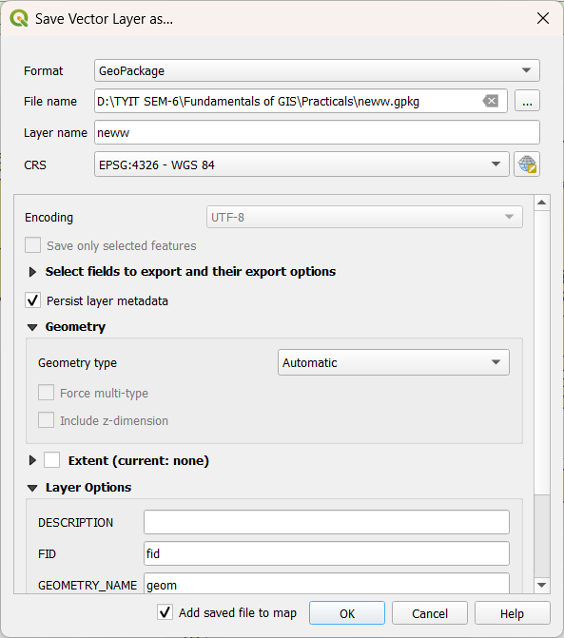

Select EPSG:4284 CRS or any CRS > Click Ok >

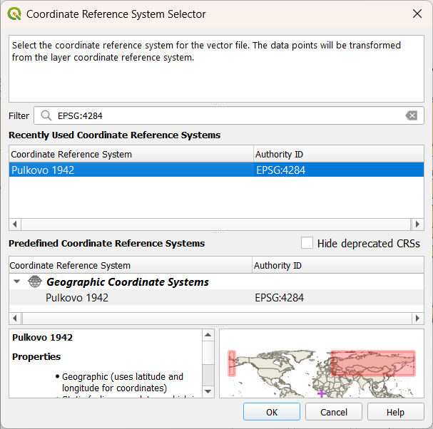

After Selecting CRS > Click Ok >

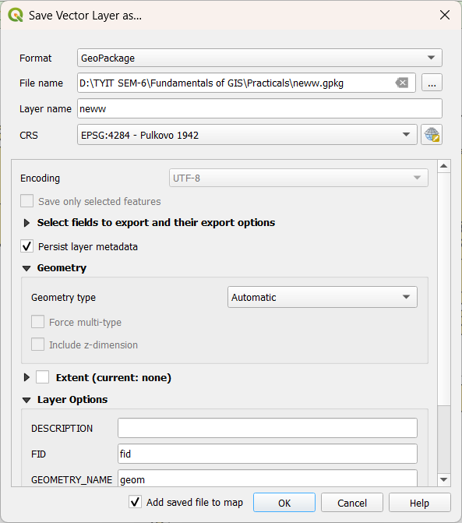

Output After Changing Projection >

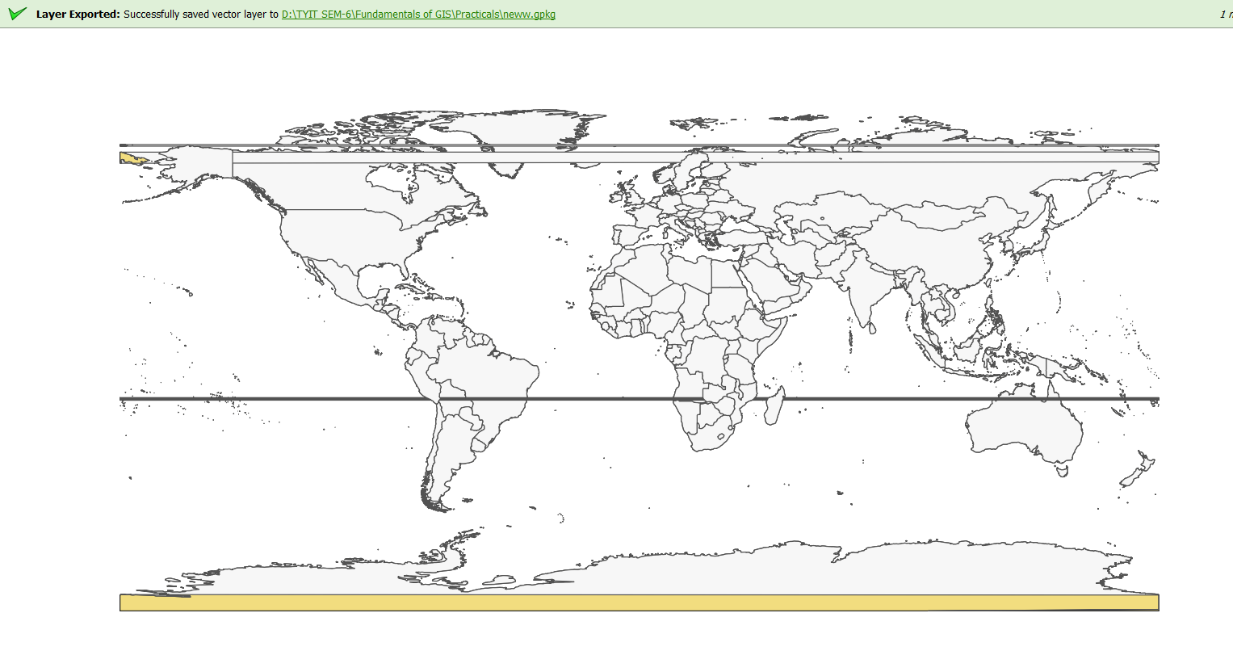

**Working with Projections and WMS Data**

Layer > Add Layer > Add Raster Layer >

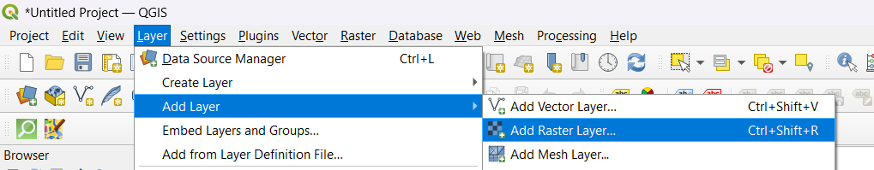

Select MiniScale_(standard)_R17 TIF file > Open >

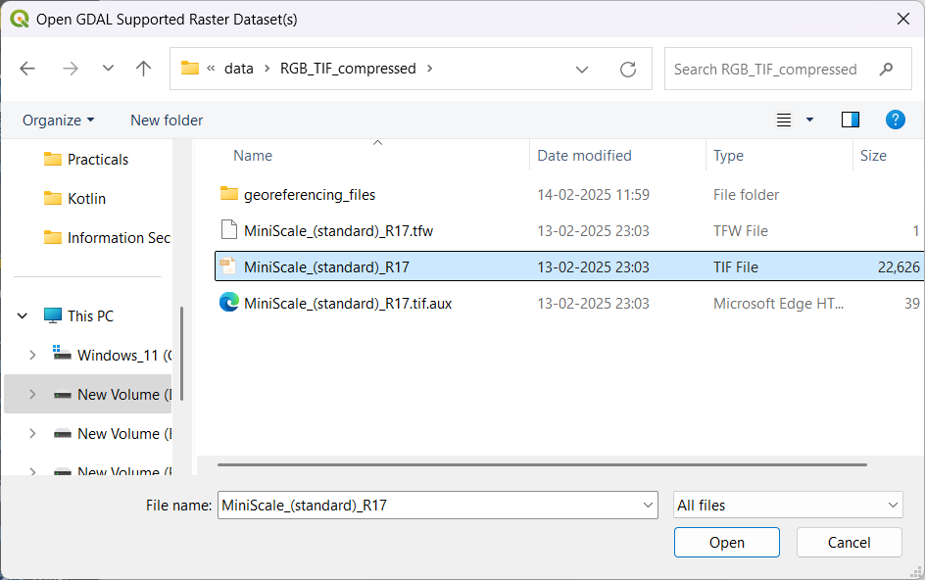

Add MiniScale_(standard)_R17.tif >

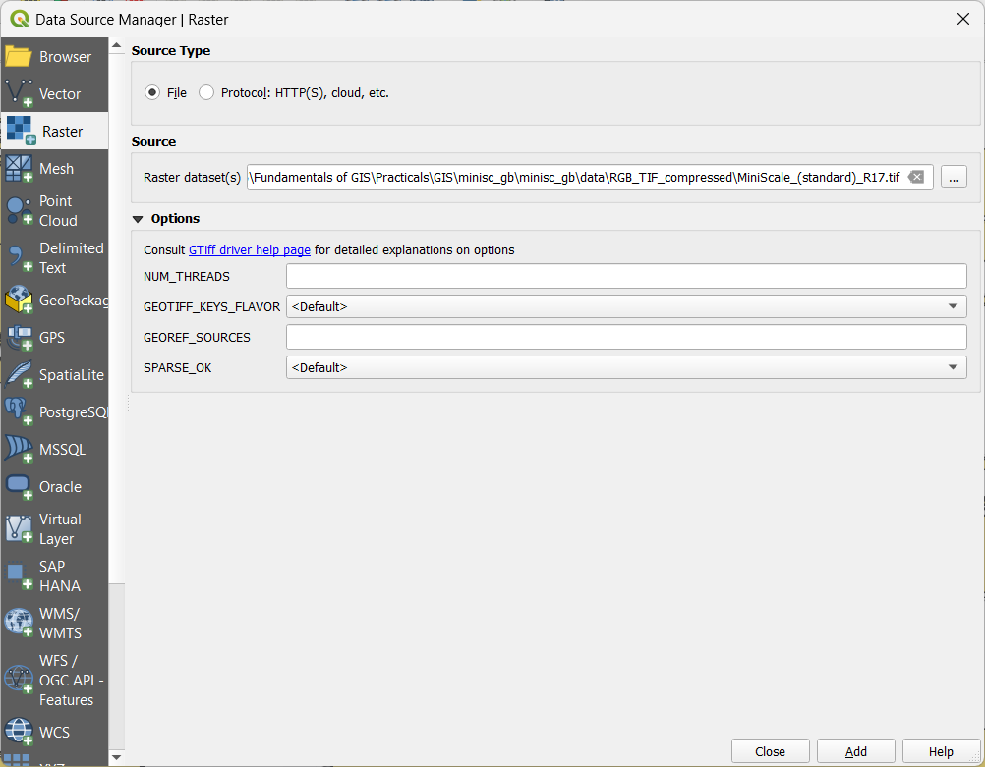

Output after adding MiniScale_(standard)_R17.tif >

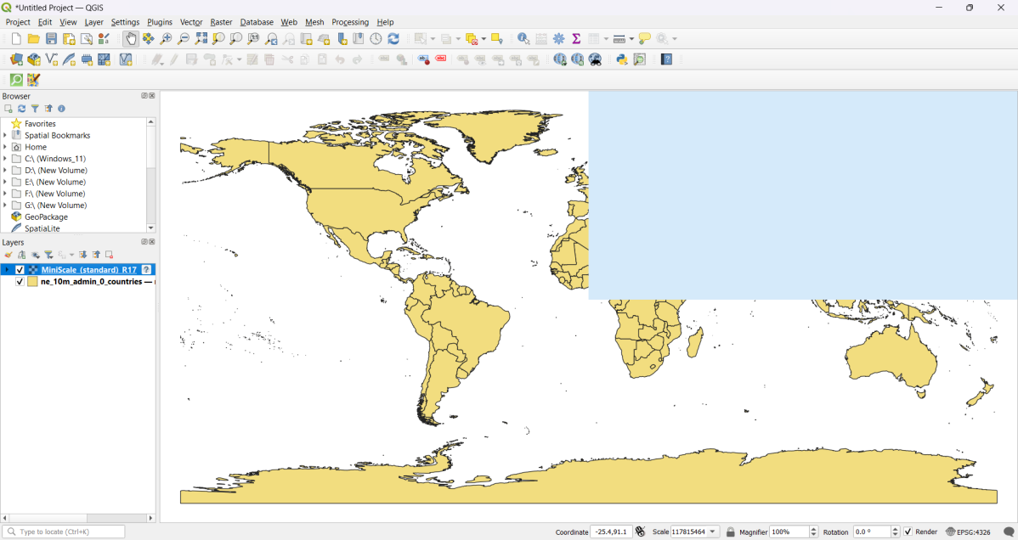

Open properties of MiniScale_(standard)_R17 layer > Select coordinate reference system(CRS) >

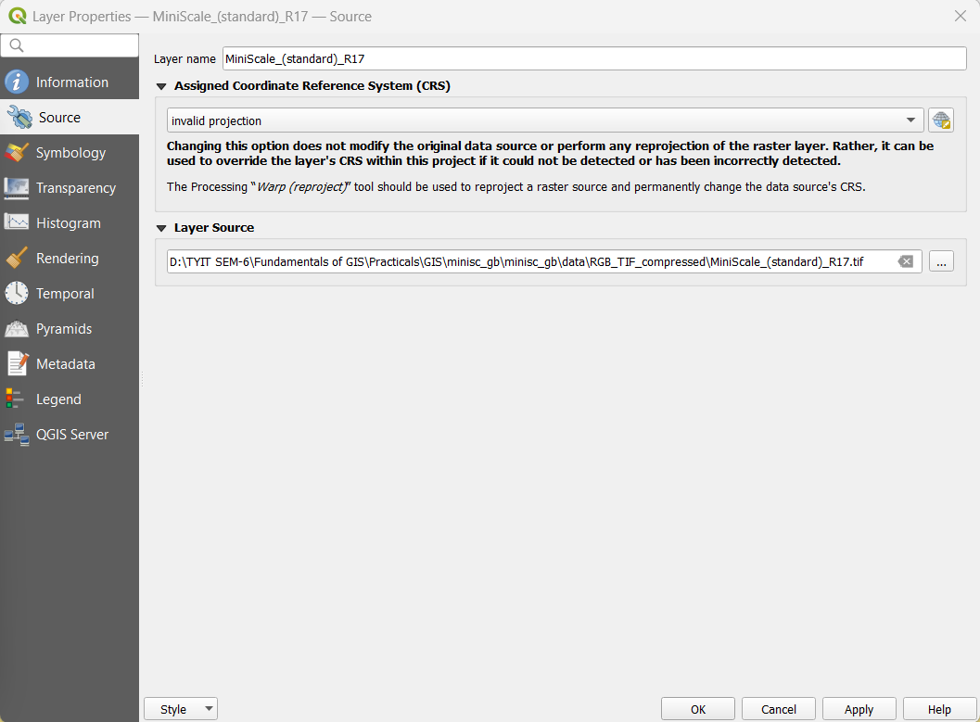

At CRS Search EPSG:27700 at Filter > select British National Grid > Ok >

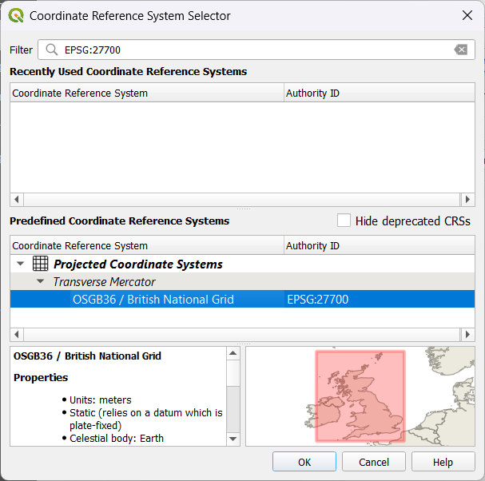

Select Defaut transformation > Ok >

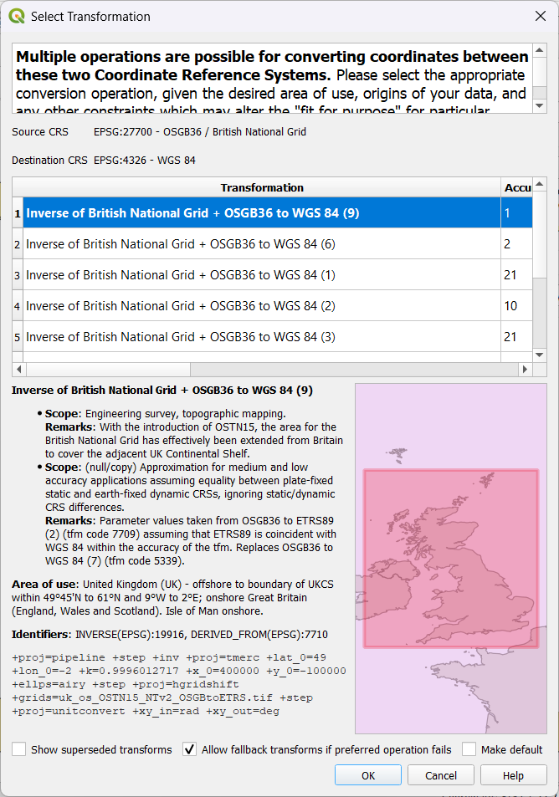

Click Ok at Properties with EPSG:27700 CRS >

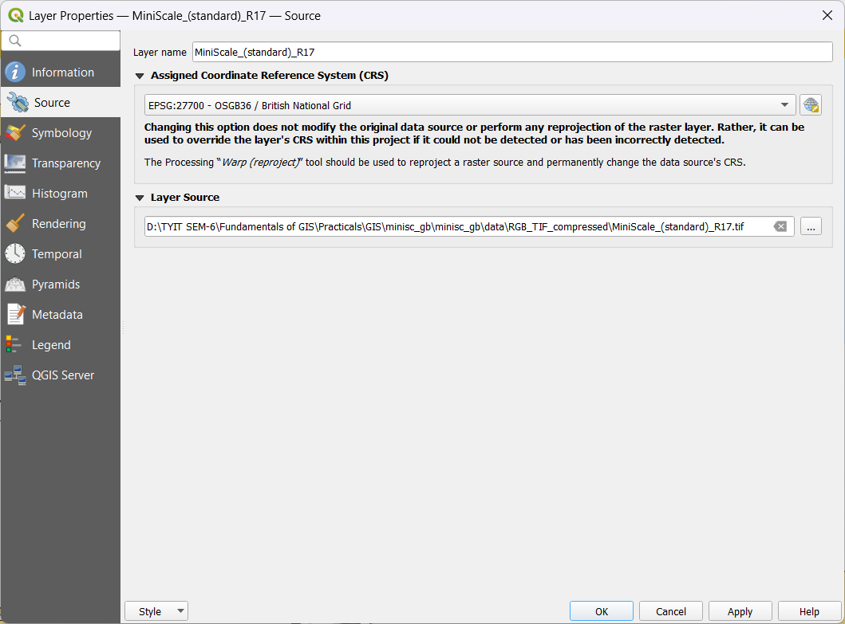

Output after adding EPSG:27700/ British National Grid CRS >

